13. Dataset: Geographic Data
1. Map Chart
Aim:
To create a geographic map chart in R to visualize the distribution and location of different cities using latitude and longitude.
Code:
# Install packages if needed
# install.packages("ggplot2")
library(ggplot2)
# Create dataset
data <- data.frame(
City = c("City A", "City B", "City C"),
Population = c(500000, 700000, 600000),
Avg_Temperature = c(75, 68, 80),
Elevation = c(1000, 800, 1200),
Latitude = c(13.08, 12.97, 17.39),
Longitude = c(80.27, 77.59, 78.49)
)
# Create map
ggplot(data, aes(x = Longitude, y = Latitude)) +
geom_point(aes(size = Population, color = Avg_Temperature)) +
geom_text(aes(label = City), vjust = -1) +
labs(
title = "Geographic Distribution of Cities",
x = "Longitude",
y = "Latitude",
size = "Population",
color = "Avg Temperature"
) +
theme_minimal()

Output:
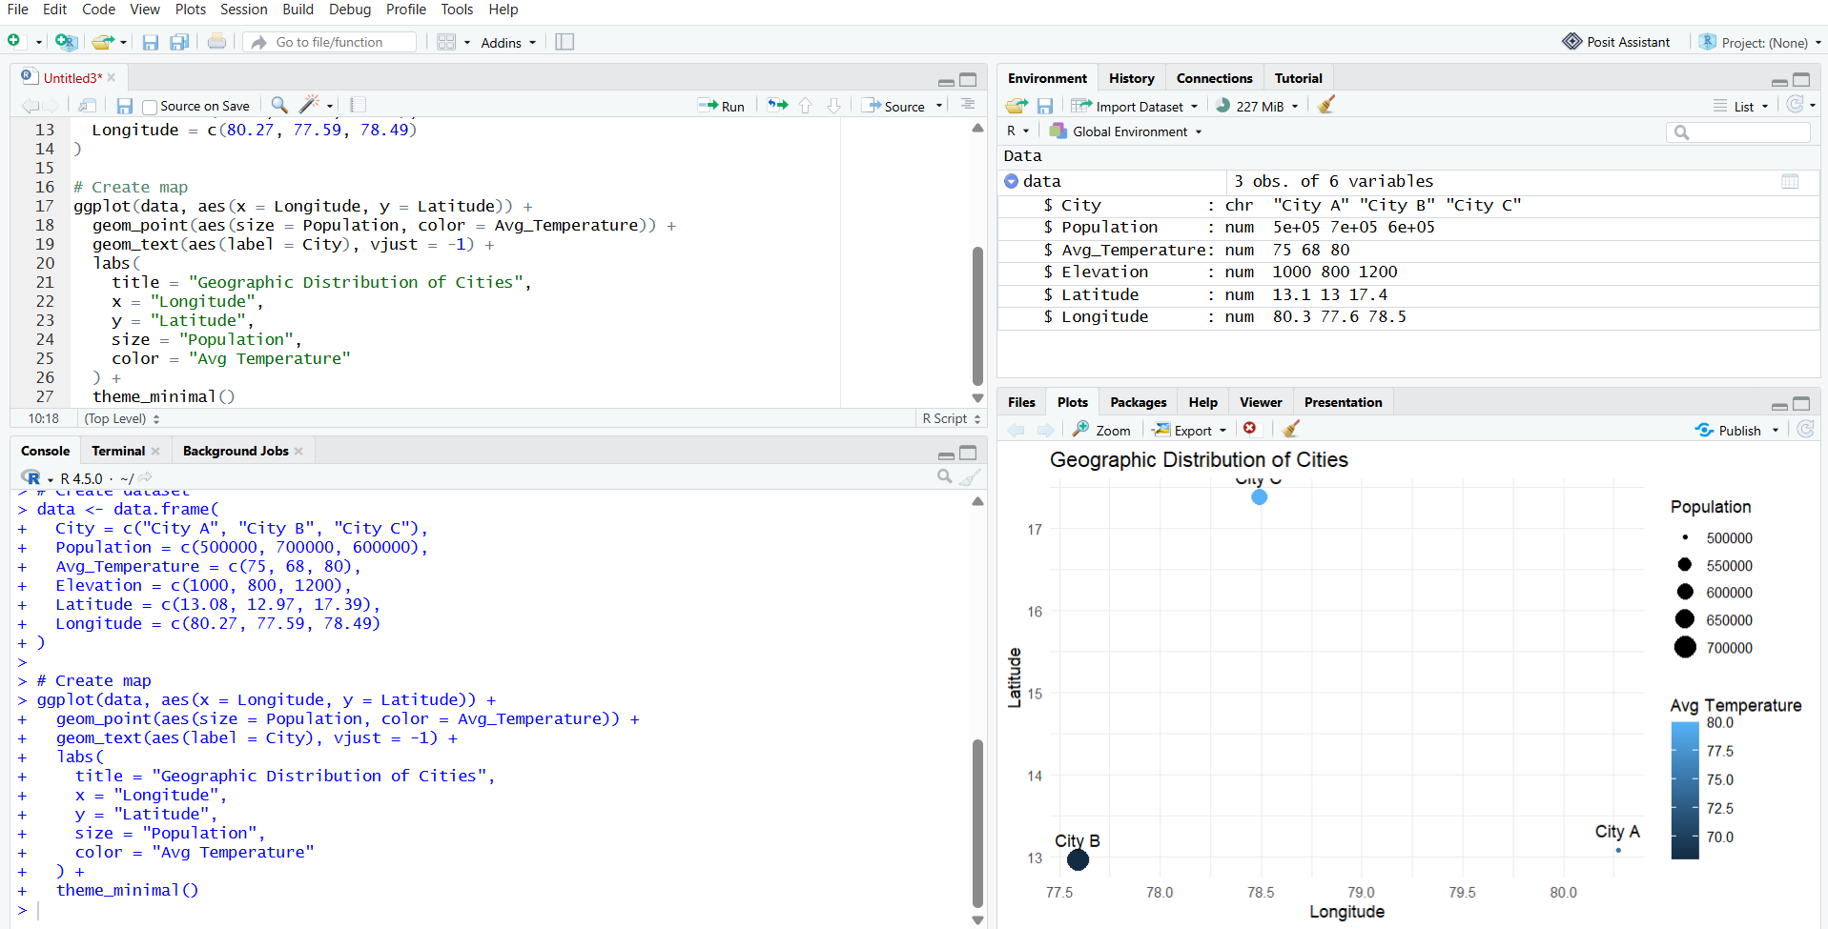
2. Scatter Plot
Aim:
To create a scatter plot in R to analyze the relationship between average temperature and population of different cities.
Code:
library(ggplot2)
# Create dataset
data <- data.frame(
City = c("City A", "City B", "City C"),
Population = c(500000, 700000, 600000),
Avg_Temperature = c(75, 68, 80),
Elevation = c(1000, 800, 1200)
)
# Scatter plot
ggplot(data, aes(x = Avg_Temperature, y = Population)) +
geom_point(size = 4) +
geom_text(aes(label = City), vjust = -1) +
labs(
title = "Average Temperature vs Population",
x = "Average Temperature",
y = "Population"
) +
theme_minimal()
Output:
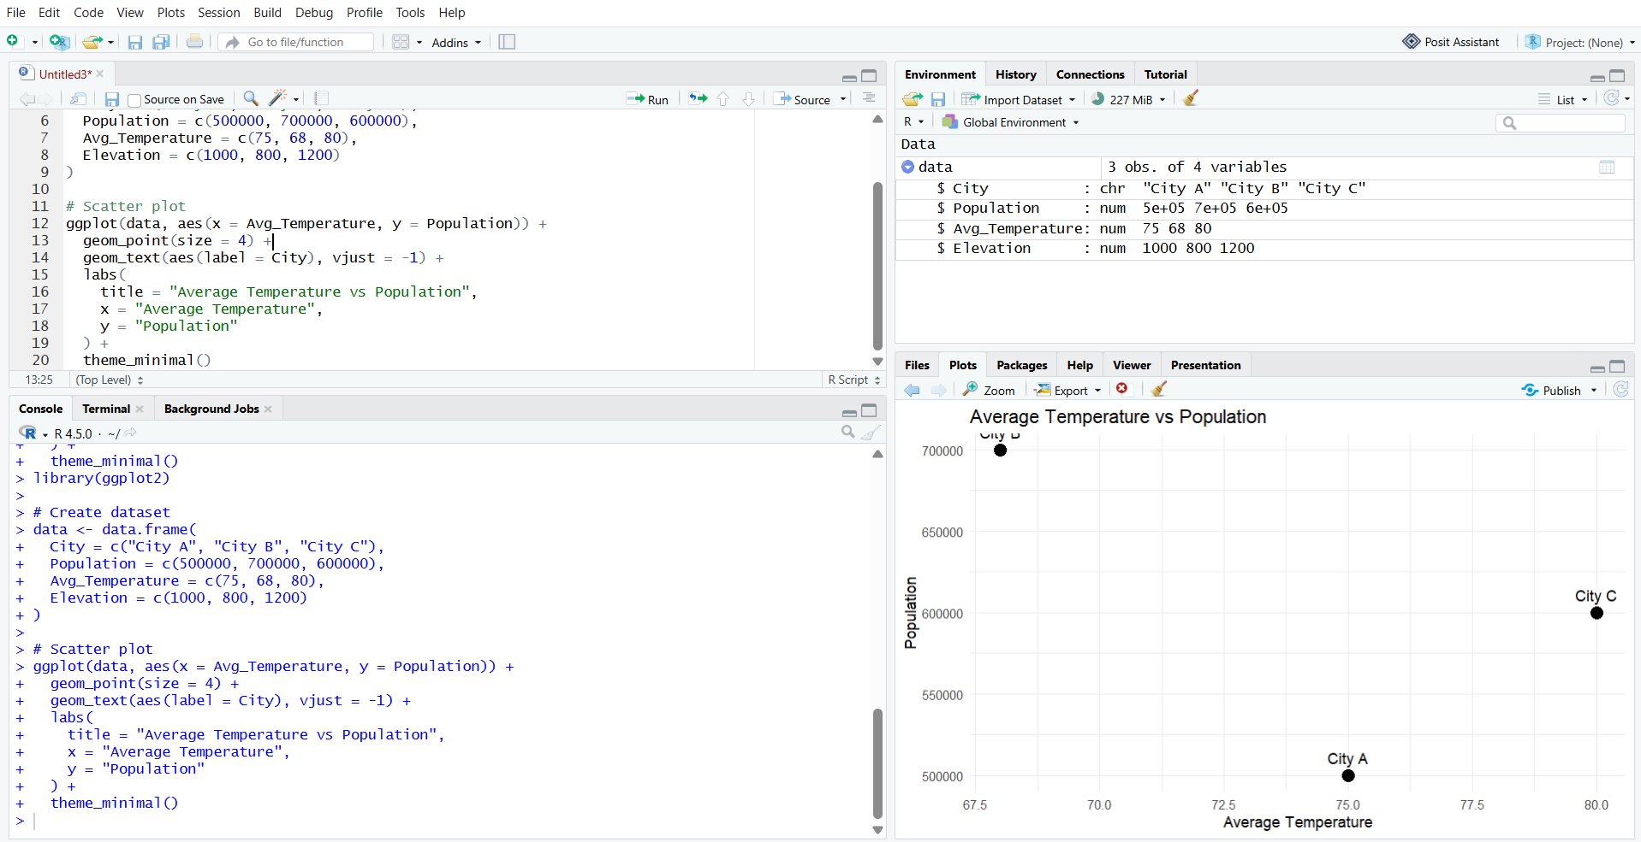
3. Table
Aim:
To create and display a table in R containing the geographic data such as city, population, average temperature, and elevation.

Code:
# Create geographic dataset

data <- data.frame(
City = c("City A", "City B", "City C"),
Population = c(500000, 700000, 600000),
Avg_Temperature = c(75, 68, 80),
Elevation = c(1000, 800, 1200)
)
# Display table
print(data)
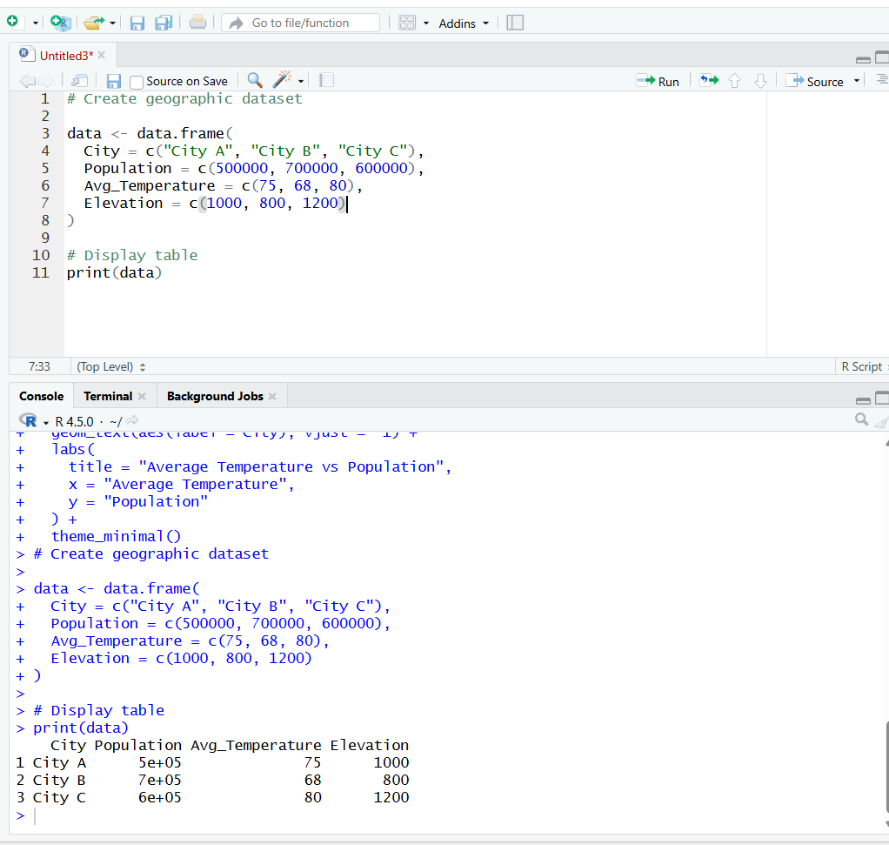

4. Dashboard
Aim:
To develop an interactive dashboard combining the map chart, scatter plot, and geographic data table for effective exploration and visualization of the data.
Output:
